MOBILE PHONE RECOMMENDER USING MULTI CRITERIA DECISION MAKING ALGORITHM

A PROJECT REPORT

Submitted by
PRRIYAMVADHAA M A (211616205078)
PURUSHOTHAMAN U (211616205079)
SAADANA S (211616205085)

in partial fulfilment for the award of the degree

Of
BACHELOR OF TECHNOLOGY
IN
INFORMATION TECHNOLOGY

RAJALAKSHMI ENGINEERING COLLEGE, THANDALAM

ANNA UNIVERSITY: CHENNAI 600 025
MARCH 2020

ANNA UNIVERSITY: CHENNAI 600 025

BONAFIDE CERTIFICATE

Certified that this project report titled "MOBILE PHONE RECOMMENDER USING MULTI CRITERIA DECISION MAKING ALGORITHM" is the bonafide work of "PRRIYAMVADHAA.M.A (211616205078), PURUSHOTHAMAN.U (211616205079) and SAADANA.S (211616205085)" who carried out the project work under my supervision.

SIGNATURE SIGNATURE

DR. L.PRIYA Mr. R. Babu

HEAD OF THE DEPARTMENT SUPERVISOR

Information Technology Information Technology

Rajalakshmi Engineering College, Rajalakshmi Engineering College,

Rajalakshmi Nagar, Thandalam, Rajalakshmi Nagar, Thandalam,

Chennai- 602 105 Chennai - 602 105.

This project report is submitted for the University Project Viva-Voice held

on __________

INTERNAL EXAMINER EXTERNAL EXAMINER

ACKNOWLEDGEMENT
We thank the Almighty God for the successful completion of the project. Sincere thanks to our Chairman Mr. S. MEGANATHAN B.E, F.I.E., for his sincere endeavour in educating us in his premier institution.
We would like to express our deep gratitude to our beloved chairperson Dr.(Mrs.)THANGAM MEGANATHAN, Ph.D., for her enthusiastic motivation which inspired us a lot in completing our project.
We also express our gratitude to our principal Dr.S.N. MURUGESAN, Ph.D., who helped us in providing the required facilities for completing the project.
We would like to thank our Head of the Department of Information Technology Dr. L. Priya, Ph.D., and the project coordinator Mrs. A. Sathya, for their invaluable guidance and encouragement for completing the project.
We are also thankful to Mr. R. Babu, Department of Information Technology for his invaluable guidance, ideas, and encouragement for the successful completion of this project.

ABSTRACT

The best smartphones are hard to pick from the diverse brands available across the globe. It is a bewildering task to choose a smartphone that suits the user’s criteria. The goal of the project is to provide a list of smartphones that is best suited to the user criteria and make their work easier in choosing their perfect smartphone. The smartphones will be listed based on the filters provided by the users. The filters will have attributes like prize, camera, OS, brands, ROM and RAM, etc. Each attribute of filters will have a priority table based on which suggestions will sort form the highest to the lowest priority. AHP-weightage will be used to prioritize the attributes. The outcome of the project is in the form of a user-friendly website that gets inputs to form the user in the form of filters and provides the best ranking list of mobiles in a timely response. The project uses various MCDM (Multicriteria Decision Making) algorithms such as Promothee 1 and 2; topsis for ranking the attributes based on AHP weightage and concludes which algorithms are best suited in terms of time and space efficiency.
KEYWORDS: Mobile Suggestions, Website, Filters, MCDM algorithms, Efficiency

CONTENTS

Chapter No. | Title | Page No
1. | INTRODUCTION | 9
 | 1.1 Introduction to Mobile Recommender Websites | 9
 | 1.2 Objective | 9
 | 1.3 Organization of the report | 10
2. | LITERATURE REVIEW | 11
 | 2.1 Introduction | 11
 | 2.2 Related work | 11
 | 2.3 Conclusion | 18
3. | SYSTEM ANALYSIS | 18
 | 3.1 Introduction | 18
 | 3.2 Existing System | 18
 | 3.2.1 Limitations of Existing system | 19
 | 3.3 Proposed System | 19
 | 3.3.1 Advantages of proposed system | 20
 | 3.3.2 Applications of proposed system | 20
 | 3.4 Hardware and Software requirements | 21
 | 3.4.1 Hardware Requirements | 21
 | 3.4.2 Software Requirements | 21
 | 3.5 Conclusion | 21
4. | SYSTEM DESIGN | 22
 | 4.1 Introduction | 22
 | 4.2 Block Diagram | 22
 | 4.3 Module Description | 23
 | 4.3.1 General Search and Find the match | 23
 | 4.3.2 Select the filters | 23
 | 4.3.3 Find the match using MCDM | 24
 | 4.3.4 View the available brands and display the result | 24
 | 4.4 UML Diagram | 24
 | 4.4.1 Use case diagram  4.4.2 Sequence diagram  4.4.3 Activity diagram | 24  25  26
 | 4.5 DFD | 28
 | 4.6 Conclusion | 29
5. | SYSTEM IMPLEMENTATION | 29
 | 5.1 Introduction | 29
 | 5.2 Algorithm for overall process | 30
 | 5.3 Algorithm Description | 31
 | 5.3.1 AHP | 31
 | 5.3.2 Promothee | 32
 | 5.4 Snapshots | 33
 | 5.5 Conclusion | 37
6. | SYSTEM TESTING | 37
 | 6.1 Introduction | 37
 | 6.2 Type of testing used | 37
 | 6.2.1 Unit Testing | 37
 | 6.2.2 Integration testing | 41
 | 6.3 Conclusion | 42
7. | CONCLUSION | 42
 | REFERENCES | 43
 | APPENDIX | 46

LIST OF FIGURES

Figure No | Name of the figure | Page No
3.1 | Detailed design for proposed system | 20
4.1 | Block diagram | 23
4.2 | Use case diagram | 25
4.3 | Sequence diagram | 26
4.4 | Activity diagram | 27
4.5 | DFD | 28
5.1  5.2  5.3  5.4  5.5  5.6  5.7  6.1  6.2  6.3 | Algorithm for overall process  AHP  Promothee  Home Page  Filter Page  Search results  Selected Mobile Phone  Input to the system  Output from the system  Test case data | 30  32  33  33  34  35  36  40  40  41

LIST OF ABBREVIATIONS

ACRONYM EXPLANATION
MCDM Multi Criteria Decision Making Algorithm
UML Unified Modelling Language
DFD Data Flow Diagram
AHP Analytical Hierarchical Process

CHAPTER 1
INTRODUCTION

  - INTRODUCTION TO MOBILE RECOMMENDER WEBSITES
In the modern world, people are moving towards an easier method of online purchasing to limit their time spent on those tasks. To make it more comfortable for the customer's several commercial service providers are digitizing their domain of business. In today’s scenarios, several commercial websites for online shopping have emerged in the markets, which allows the customers to perform their shopping work online and their products are being delivered at the doorstep. This process has numerous advantages in regards to time-saving and marketing products at cheaper rates, but a question arises whether the customers who are searching for a particular product are being provided with appropriate services without diverting them from their original intention. In most of the websites in today’s modern market, it mentally forces the customers to buy the products which they are not originally needed. This proposed system, suggests a commercial website for mobile phones which will enable the customers to search their required product without any kind of external diversion. This proposed system asks the customer to choose the filters for the particular product they want to purchase. Customers are also provided with an additional option of choosing the priorities for each individual filter so that the system may recommend the products which are more suited to them according to their priorities.

  - OBJECTIVE
The objective is to provide an integrated platform for the customers which enable them to search a particular product across different service providers. This platform will suggest a number of recommendations based on their priorities.

  - ORGANIZATION OF THE REPORT
Literature Survey
The Chapter 2 deals with the explanation of various reference papers of the researchers. The methodologies, theories, limitations over the system are analyzed.
System Analysis
The Chapter 3 deals with an explanation on the proposed system. The existing system and its limitations are analysed. The proposed system with its advantages, applications and the hardware requirements are discussed.
System Design
The Chapter 4 deals with System Design that describes the System Architecture. The Unified Modelling Language and Dataflow diagram for the system are designed in this section.
System Implementation
The Chapter 5 deals with System Implementation that describes various algorithms like AHP, Promothee. The techniques and methodologies to solve the existing system is discussed. Snapshots of the working Graphical User Interface is also provided for better understanding of the system.
System Testing
The Chapter 6 deals with System Testing that gives a detailed explanation on the various testing used such as Unit testing, Integration Testing. Test case data and their results are discussed.
Conclusion and Future Work
The Chapter 7 deals with an overall review of the report along with work that can be implemented in the future.

CHAPTER 2
LITERATURE REVIEW

2.1 INTRODUCTION
A literature review is a survey of sources on a specific topic. Mobile phone recommender system works on the MCDM technique that involves customer to view their desired product based on a certain strategy. This strategy further demands algorithm to produce the desired result for the customer. Thereby to identify relevant theories, methods, and gaps in the existing research, the related works have been discussed.
2.2 RELATED WORK

Philip Achimugu et.al (2014) stated a system [1] is a web-based system that focuses on providing software requirements that are prioritized by the MCDM technique. The approach offers a brief way of involving stakeholders in the entire decision-making process irrespective of their position in an automatic fashion. The stakeholders select the project software requirements from the suggested optimal tool recommender. Thereby it promotes an efficient way of building an application. The system also is proposed to give an outcome that prioritizes the requirement with the graph showing the requirements in chronological order.
Limitations: The system never talks on user-specific needs but only provides a suggestion of optimal requirements to be used to build a project.

Georges Adulin et.al (2014) proposed a model [2] that the systematic review and bibliometric analysis in healthcare have become important and lack the analysis in these areas. Thereby to systematically identify the applications and report on publication trends in healthcare, he proposed a system that involved optimal decision making of the search strategies. The search terms were used along with side the Boolean operators. Various reference lists of previously published reviews were identified and scrutinized for relevant citations. The trends were analysed. Various publishes of healthcare were identified by the year of publications, MCDA technique, type of intervention and application area. The systematic review thereby identified search results of about 205 publications, of these, some were duplicates and some didn’t meet the expected search criteria. Only the optimized searches were reviewed, reported and included. Further, he also stated that research is needed to develop practice guidelines for the appropriate application and reporting of MCDA methods.

Limitations: Approach may not be optimal where it produced many duplicate search results.
Vijay Manikrao Athawale et.al (2010) Stated [3] that the location selection for a manufacturing industry is a tedious process. There are many attributes of alternatives involved such as resource, cost, production capacity, distribution network, etc. If any of these is less than the good scalability, then it leads to major loss to the organization. This method uses multi-criteria decision making PROMETHEE 2 algorithm to select the best manufacturing land.
Limitations: The heavy computational cost when a system requires a high model order operating on high dimensional data.
Vahid Balali et.al (2012) Stated [4] that the process of constructing a structural system for a construction site is an overwhelming task for civil engineers. They need to take both technical and economic criteria for the construction of the best system. To choose the best construction site the best decision as to be made when the user provide the criteria needed for the best site. This paper has combined two multi-criteria decision techniques (electric 3 and PROMETHEE 2) and proposed a decision-making system with the aggregation of both the techniques. This proposed system helped in selecting the appropriate structural system.
Limitations: The system provided more than the accurate search result when searched.

Harry Barton et.al (2008) stated [5] that the police forces in the UK are periodically compared with each other on their performance, by government and non-government bodies. This study demonstrates the use of PROMETHEE in an investigation of the targeted performance rank improvement of individual UK police forces (with their ‘most similar forces’ groups). The graphical representations show an insight that the application of such a PROMETHEE based series provides an improvement analysis. The goals of this study are twofold, firstly to take advantage of PROMETHEE based uncertainty analysis in the rank improvement and secondly, how the next results can form a part of the evidence to assist in their performance strategies.
Limitations: No optimized decision making available.
Darius Danesh et.al (2017) proposes a model [6] that the successful delivery of objectives of an organization, selection of project portfolios is important. They are different MCDM techniques to make a decision. This system uses hundreds of techniques and experimented with thousands of portfolios to pick a perfect project portfolios, after successful experimentation they narrowed down to eight suitable techniques such as analytic hierarchy process (AHP), analytic network process (ANP), data envelopment analysis (DEA), elimination and selection expressing the truth (ELECTRE), preference ranking organization method for enrichment evaluations (PROMETHEE), technique for order preference by similarity to ideal solution (TOPSIS), analytic hierarchy process (AHP), dominance-based rough set approach (DRSA), and VlseKriterijumska Optimizacija I Kompromisno Resenje (VIKOR)]. After repeated constructive review with these eight techniques, they concluded AHP and DEA are best suited to find the project portfolio helpful is maintaining the organization's objective.
Limitations: Only various techniques were provided optimal solution is yet to be achieved.
Anissa Frini et.al (2012) stated a system [7] with the intensification of chronical disease within older people, concurrent use of different drugs (poly-pharmacy) is becoming increasingly frequent. However, there is no established manner to determine whether poly-pharmacy is appropriate or not. They propose an original method of classifying poly-pharmacy using multi-criteria decision-aid methods. To do this, they provided clinicians with a list of drugs that could be potentially prescribed to the typical elderly person suffering from three diseases (diabetes, chronic obstructive pulmonary disease, and heart failure). Clinicians expressed their opinion on a 5-point Likert scale, allowing for hesitation between two or more answers. They evaluated the risks, benefits, and impacts of each drug on the patient’s quality of life. They then aggregated these evaluations to get, for every drug, a multi-criteria evaluation vector representing the collective opinion of the clinicians consulted. Subsequently, ELECTRE Tri-C and ELECTRE Tri multi-criteria methods were used to evaluate and assign the poly-pharmacy to one of the following three categories: appropriate, more or less appropriate, or inappropriate.
Limitations: There were many Hesitation between two or more answers among the clinical experts.
Majid Khalaji et.al (2012) stated a system [8] for a recommendation of E-commerce products. He mainly focused to style a Recommender System using association of complementary and similarity among goods and commodities and offer the only goods supported personal needs and interests. Also, the other purpose of this paper is to solve some problems, such as the old start and scalability. These problems are involved in many Recommender Systems. He also divided the system into many categories and solves the issues in a recommendation. The system moreover not focuses on one particular product and focuses on the similarities between them.
Limitations: The system has chances to divert the user from a specific task in choosing the product.

Axel C. Muhlbacher et.al (2015) stated a system [9] that The Healthcare decision making is a tedious task as it needs to cover the overall patient preferences, insures and experts involved. MCDA also needs to focus on local, national and international needs. He also states that MCDA provides transparency in healthcare decision making. MCDA provides more diversity of approaches and applications within specific healthcare situations. Various patient assessment levels and clinical endpoints are considered with an aim to generate patient-relevant benefit data of an intervention. They provide optimized results on what facilities the patients require, the expert needed to be based on MCDM.
Limitations: Expert selection by decision making has not been studied to date but could lead to interesting insights.
U. Oses et.al (2018) stated a system [10] that It is a tedious process for any local government to improve urban transportation. Numerous criteria should be taken into account for improving sustainability. This paper used a multi-criteria decision-making algorithm to find an area that has weaker sustainability and improve them. However, this paper does not focus on the criteria that include the attributes of the cities which has a major impact on the decision-making process.

Limitations: The system does not focus on the criteria that include the attributes of the cities which has a major impact on the decision-making process.

Sharmistha Roy et.al (2018) stated a system [11] that E-commerce enables a firm or an individual to establish a market or enhance an existing market position over the internet, by providing efficient business chain and low-cost product and service. Mr. Sharmistha Roy focuses on a comparative study of three main MCDM algorithm that provides basic results as per user needs and their interests in choosing a product from an E-Commerce web site. AHP decomposes the decision problem into criteria, sub-criteria, and alternative forming a hierarchy. PROMETHEE is another Multi-Criterion Decision-Making method that finds the best alternatives. TOPSIS ranks the choice supported the space between positive and negative ideal solution. Though he has proposed individual algorithms functioning.

Limitations: Combined analysis or providing an optimal solution without diverting the user interests are not satisfied.

Abhishek Srivastava et.al (2017) stated a system [12] The paper decides the features that will help in designing the crash-free system. For deciding which criteria has the major weightage in the system crash scenario, it used a multi-criteria decision-making algorithm - DEMATEL. By using this it designed a system with fewer chances of getting a crash.

Limitations: Obtaining an Optimal solution is difficult.
Patrick Taillandier et.al (2011) stated a model [13] that the exploration of an unknown environment by a robot system; an individual robot or a team of robots; is a well-studied problem in robotics. This problem mainly focuses on finding victims after a disaster. Most of the proposed exploration algorithms are supported by the utilization of specific criteria to define the standard of the possible movements. In this paper, the system proposes a search approach that supported the mixture of several criteria because of the PROMETHEE II multi-criteria deciding method. The PROMETHEE II method allows one to determine an entire ranking between possible movements supported outranking relations. Experimental results show that this approach is often wont to effectively combine different criteria and outperforms several classic exploration strategies.
Limitations: Obtaining an Optimal search solution is difficult when an individual algorithm is used.

Ziming Zeng et.al (2010) stated the system [14] that integrates semantic retrieval and multi-attribute decision method. First, semantic similarity is computed by constructing semantic vector-space, to understand the semantic consistency between retrieved results and customer’s query. Besides, the TOPSIS method is additionally utilized to construct the comparison mechanism of the commodity by calculating the utility value of every retrieved commodity. Finally, the experiment is conducted in terms of accuracy and customer acceptance rate, and therefore the results verify the effectiveness of the model and it can improve the precision of the commodity information search.

Limitations: Comparison mechanism with decision making has not been studied to date but could lead to interesting insights.

Hongju Zhao et.al (2013) stated a system [15] to improve efficiency in a timely response; an experiment has been conducted by integrating multiple steps of traditional PROMETHEE into one formula so that it reduces computational complexity, comparisons, etc. A test is done by comparing the traditional PROMETHEE and modified PROMETHEE by providing the alternatives of earthquake. The outcome of the test showed more efficiency in modified PROMETHEE. But the proposed method does not prove the influence of the size.

Limitations: Combined analysis or providing an optimal solution without diverting the user interests is not satisfied.

2.3. CONCLUSION
The literature review helps the reader to understand different aspects posed by the research on the MCDM methodologies. Some efficient search-based algorithms such as AHP, Promothee when worked together produce optimal results. This can be inferred from the related works. Redundancy of the data can be avoided. It is also further analysed that combined analysis of algorithm may provide optimal solution without diverting the user interests.

CHAPTER 3
SYSTEM ANALYSIS
3.1 INTRODUCTION
System analysis is a process of collecting, interpreting facts, identifying the problems, and decomposition of a system into its components. System analysis is conducted for this purpose to study the system or its parts in order to identify its objectives. It consists of problem-solving techniques that improves an existing system and ensures that all the components of the system work efficiently to accomplish their purpose in comparison with a proposed system.

3.2 EXISTING SYSTEM
The existing system focused on providing search results based on the mentioned filters. But it failed to produce accurate results. Details or the search results were sorted based on the parameters specified thus making it convenient yet it did not satisfy the accurate condition needed. The system focused on providing results on the conditions specified, no priorities were set up to enhance the search results. Hence the search results also promoted other results to be displayed irrespective of the required condition that was specified. There was no recommendation option that was provided to enhance the search by users.
3.2.1 Limitations of Existing System
- When a user searches for a product in online the respective service provides will only list the items available with them.
- It is always a tedious process for the user to search in different platforms for a single product.
- There is a possibility for a platform to list other irrelevant products other than user needs, which tends to divert them from their task.

3.3 PROPOSED SYSTEM
The system extracts the required criteria from the customer and the products are listed according to their needs. This system also provides the list of service providers who can provide the particular brand. Since, it is implemented using MCDM algorithms it can avoid the user to encounter irrelevant products. The user will be provided an option to enter the filters and assign weightage to individual attributes. The proposed system (Figure 3.1) will provide suitable recommendations to the customer along with the various service providers as an additional suggestion.

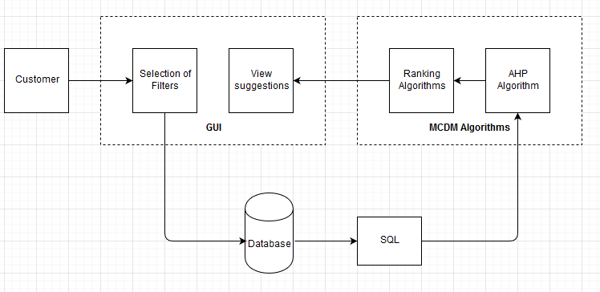
Fig. 3.1: Detailed design for proposed system

3.3.1 Advantages of proposed system
- In Existing system, the search results are obtained randomly based on the filter criteria.
- In the proposed system, the filter criteria are given a weightage through which the products are ranked.
3.3.2 Applications of proposed system
The proposed methodology is applied in order to select the most appropriate multi attribute involved products in order to reduce the confusion in buying the products. It also avoids the user from getting distracted what they originally need. Thus, encourages people to make valid decision in buying a product. The system can be used in e-commerce websites.

3.4 HARDWARE AND SOFTWARE REQUIREMENTS

3.4.1 Hardware Requirements

Processor - Intel Pentium

Speed - 1.1 GHz

RAM - 2 GB (min)

3.4.2 Software Requirements
Operating System - Windows 7/8/10
Front End - Php-HTML
Server-side Script - Php
Database - Python

3.5 CONCLUSION
In this chapter our conclusions related to each theme we introduced at the start of the report is addressed. These conclusions reflect detailed analysis of the system and the requirements for adequate support is also gathered for further implementation.

CHAPTER 4
SYSTEM DESIGN
4.1 INTRODUCTION
Systems design as shown in (Fig.4.1) is the process of defining the architecture, modules, interfaces, and data for a system to satisfy specified requirements. Systems design could be seen as the application of systems theory to product development.
4.2 BLOCK DIAGRAM:

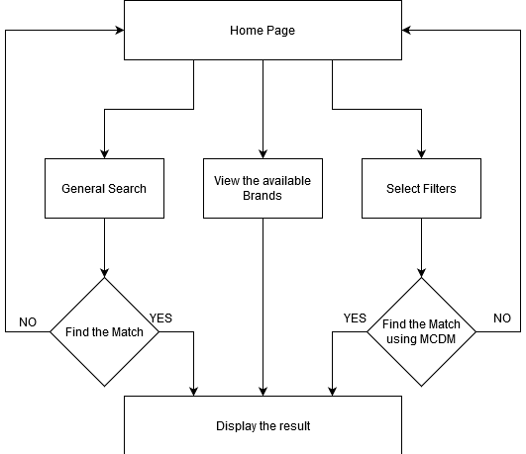

Fig. 4.1 Block Diagram

4.3 MODULE DESCRIPTION

Module 1: General Search.
Module 2: Select the filters.
Module 3: Find the match using MCDM.
Module 4: View the available brands and display the result.

4.3.1 General Search
In this module the users are provided with an option to search the products using its name or any of the specification without applying any filters. The results which are obtained were purely based on what keyword we are using to perform the search operation. The products whose data matches with the specified keyword are extracted and displayed. If no matches are found then it will redirect the user to the homepage.

4.3.2 Select the filters.
In this module the users are provided with a list of filters, So that they can exactly look for products which they want to see. They can also allot weightages to those filters according to their priorities. This module has the following filter parameters,
- Price
- Camera Rear
- Camera Front
- Display inch
- RAM
- ROM
- Android OS
- Battery
- Processor

4.3.3 Find the match using MCDM.
Those parameters which are selected by the users are assigned passed to MCDM algorithm to find the matches. This algorithm is used to allocate ranks to all those parameters based on user allocated weightages. These ranks are used to extract the products that are most suited for user needs and the preferences. The products are ranked in a manner in which all possible criteria mentioned by those users are met.
4.3.4 View the available brands and display the result.
If the user wishes to view all those brands available in the dataset then this module is useful to fulfill that purpose. This module provides every product that are available with the service provider.

4.4 UML Diagrams
The UML Diagrams depict a better view for understanding and analyzing how the system works. It conveys how various participants use the system and also delivers detailed pictorial representation of the working model.

4.4.1 Use Case Diagram
Use case diagrams as shown in (Fig.4.2) specify the events of a system and their flows will provide sufficient options for the customer who is utilizing this system to select the filters according to their needs for smartphones. The customers can also provide weightage for each filter parameter. After a sequence of operations performed in the inner layer, the user can view the predicted recommendations based on their requirements. This system will also provide a list of service providers who can offer those products to the customers

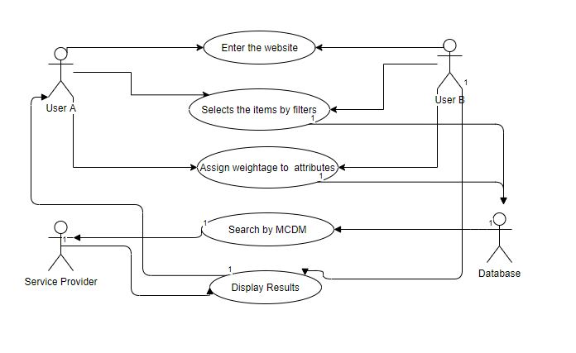
Fig. 4.2 Represents the Use Case Diagram
4.4.2 Sequence Diagram
A sequence diagram as shown in (Fig.4.3) is an interaction diagram that shows how objects operate with one another and in what order. The Mobile Phone Recommender system works with operators as follows:
- The Users enter the application and request for the item they need.
- The requested item is further processed in the background with the help of the database and list of items are displayed.
- The users further select the parameters based on the priority they need. This priority is achieved by assigning them a weight.
- This request is further processed in the web server with the help of the MCDM techniques such as AHP and Promothee.
- Optimal Solutions are displayed as per the request.

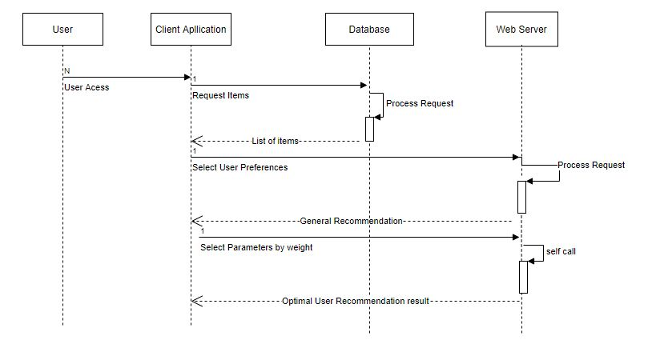

Fig. 4.3 Represents the Sequence Diagram

4.4.3 Activity Diagram
Activity diagram as shown in (Fig.4.4) is basically a flow chart to represent the flow from one activity to another activity. The activity in this system focuses between the user and the recommendation system. User is provided with two functionalities to search products based on brand name and filters to request the system to produce a result. When filters are applied the algorithms start working based on the MCDM technique to produce the optimal solution what a user request.

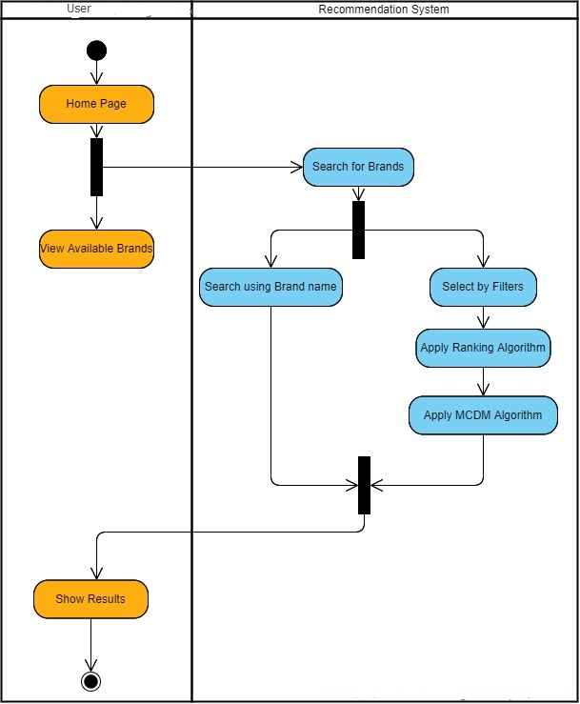

Fig. 4.4 Represents the Activity Diagram
4.5 DATA FLOW DIAGRAMS
A DFD is a graphical representation of the "flow" of data through an information system, modeling its process aspects. The overview of the recommendation system on producing an optimal solution to what a user request is achieved through a GUI.
The System flow in (see Figure 4.5) describes the flow of processes in the system architecture which details the view of data flow from one component to another.

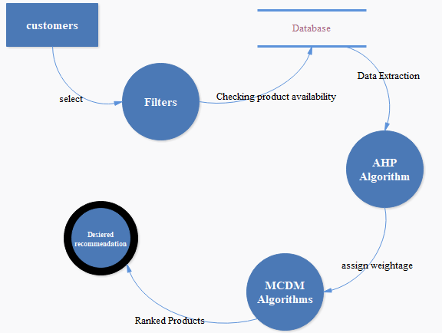
Fig. 4.5 Represents the DFD

The figure.4.5 represent the DFD diagram for proposed model. Here the customers will select the filters. The products which matches the listed filters will be extracted from the database. Then they are fed to AHP algorithm where the parameters are assigned weightages based on the priorities given along with filters by the user. These weights are passed to MCDM Algorithm where the products are ranked according to the weights. The ranked products will be produced as output for the users.

4.6 CONCLUSION
Chapter 4 thereby concludes describing what analysis specifies. It guides the system what it should do whereas the design describes how a task is accomplished. The UML diagrams and the DFDs depict further understanding of the Mobile Phone Recommender system.

CHAPTER 5
SYSTEM IMPLEMENTATION
5.1 INTRODUCTION
System implementation defines how the information system should be built and should also ensure that the information system is operational and used, information system meets all quality standards. The design of algorithms is constructed for the functioning of the project in this phase.

5.2 ALGORITHM FOR OVERALL PROCESS

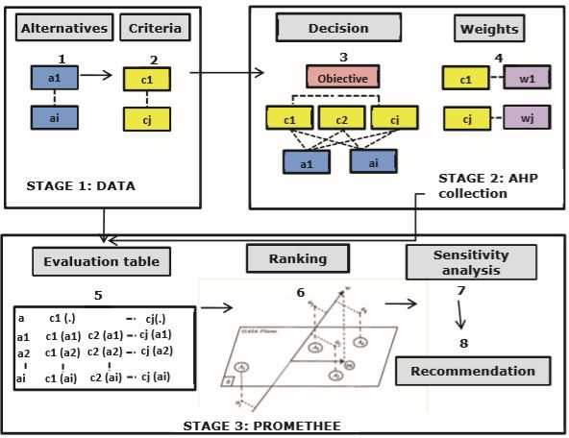
Fig. 5.1 Algorithm for overall process

The proposed AHP-PROMETHEE approach (see Figure 5.1) consists of three main stages: (1) Data collection, (2) AHP and (3) PROMETHEE.
In the first stage, the alternatives submitted for evaluation are identified (step 1). In step 2, the key objectives of the decision-makers are identified and translated into criteria on which the alternatives are going to be evaluated. The information gathered in steps 1 and a couple of is then utilized in the second stage to set-up a hierarchical decision tree (step 3). In order to precise a preference for the various criteria, weights are allocated in step 4. In the third stage, preference functions and parameter values are determined to enable the measurement of the contribution of the alternatives to the standards. With this information, the evaluation table is made in step 5. Afterwards, the alternatives are evaluated and ranked by means of partial ranking with PROMETHEE I and complete ranking with PROMETHEE II and therefore the GAIA plane (step 6). Here, the PROMETHEE deciding software D-SIGHT is employed. Special features of the software include the ‘walking weights’ or the development of ‘stability intervals’ that allow to perform sensitivity analyses and to verify the robustness of the results (step 7). Based on the knowledge from PROMETHEE I, II, GAIA and therefore the sensitivity analyses, recommendations towards the simplest compromise are often formulated (step 8).
5.3 ALGORITHM DESCRIPTION
The proposed system deals with the technique of MCDM that explicitly evaluates multiple conflicting criteria. The MCDM problems are often represented within the criterion space or the choice space. Alternatively, if different criteria are combined by a weighted linear function, it's also possible to represent the matter within the weight space. This involves integrations of two algorithms as follows:
5.3.1 AHP
In AHP, values like price, weight, or area, or maybe subjective opinions like feelings, preferences, or satisfaction, are often translated into measurable numeric relations. The core of AHP is that the comparison of pairs rather than sorting (ranking), voting (e.g. assigning points) or the free assignment of priorities.
Analytical Hierarchy Process (AHP) is used to assign weightage to the attributes as shown in (see Figure 5.2) which in turn is supplied as input to MCDM algorithms.

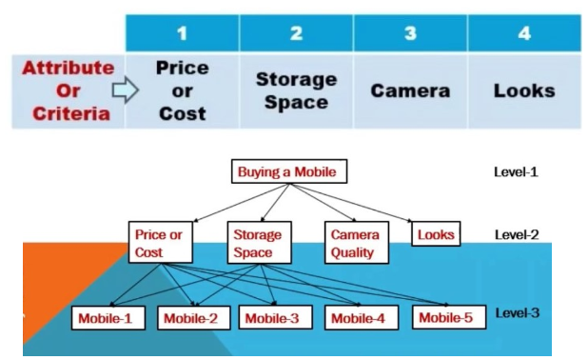
Fig. 5.2: overview of AHP - ANALYTIC HIERARCHY PROCESS

5.3.2 PROMETHEE
The PROMETHEE methods were designed to treat multicriteria problems. The PROMETHEE method is an interactive multi-criteria decision-making approach designed to handle quantitative also as qualitative criteria with discrete alternatives. In this method, pair-wise comparison of the alternatives is performed to compute a preference function for every criterion.
PROMOTHEE- 1 & 2 algorithms are usually used to rank the products based on the assigned weightage as shown in (see Figure 5.3). These ranks are usually used to arrange the products according to customer preferences.
Fig. 5.3: processing steps of PROMOTHEE

5.4 SNAPSHOTS
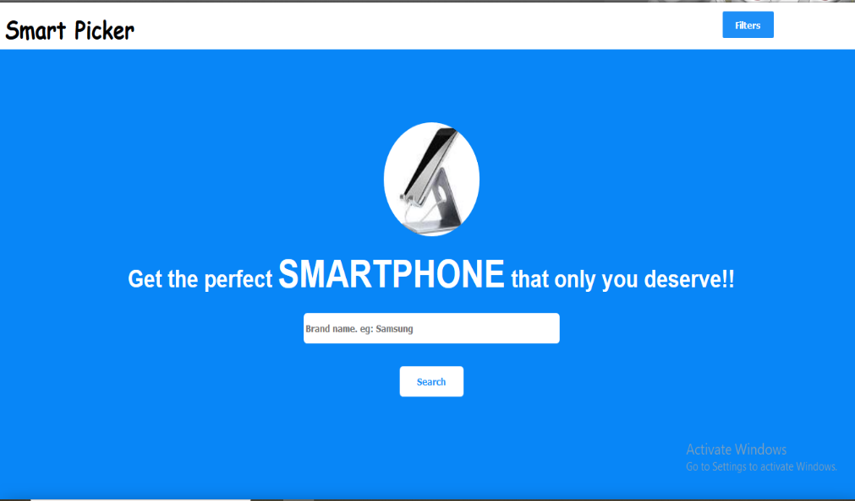
Fig. 5.4 Home page of the mobile recommender site

Figure 5.4 shows the homepage for the proposed application. The user has to enter the brand he/she is searching for. He can also view some of the brands available with the service provider. The user can also search products using filters.
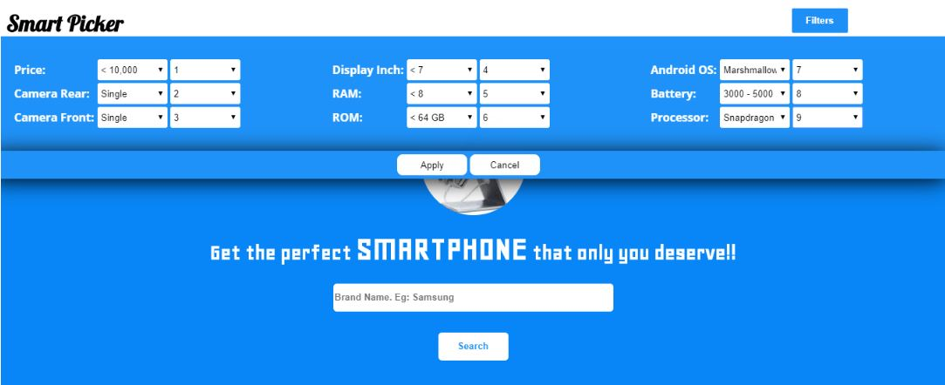
Fig.5.5 Depicts the User Search Filter Page where users can Search through the optimized attributes.

Figure 5.5 shows the Filter options that are available in the webpage. These filters can be chosen along with their priority, so that the user can display the product based on the selected filters.

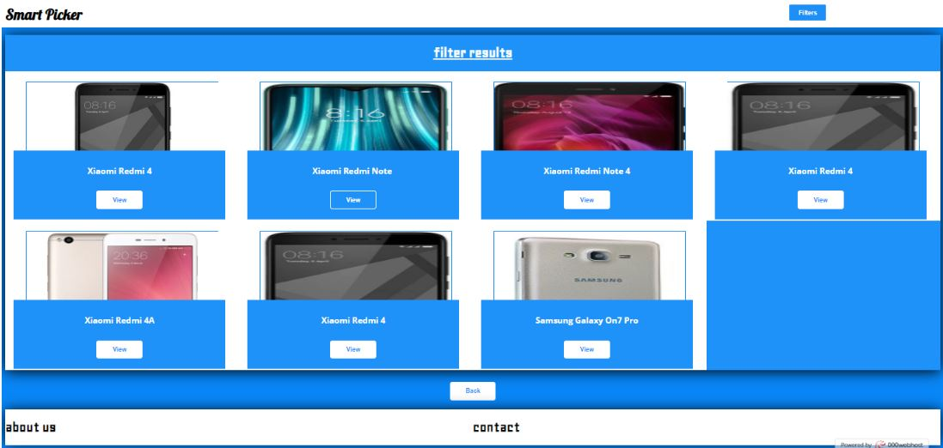
Fig.5.6 Represents the accurate search results.

Figure 5.6 represents the result page of the search. If the user searches the product using the filters then the results are displayed according to their preferences in this page. If the search is carried out based on the search box then the phones with matches the entered phrase will be listed.
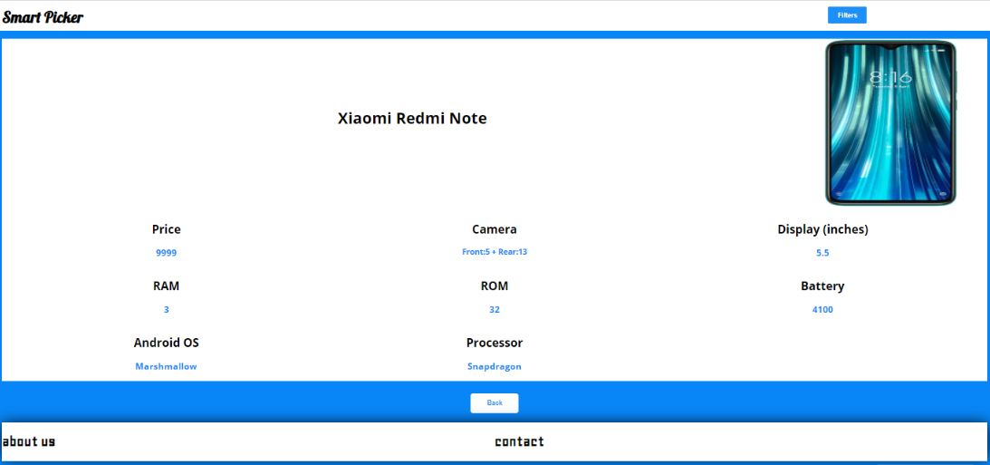
Fig.5.7 Represents the selected Mobile Phone with its features

Figure 5.7 Shows the page which will display the details about the products. When a user clicks on the view button below the product the user is redirected to this page. It lists the details such as,
- Mobile Name
- Price
- Camera Rear and Front
- RAM and ROM
- Battery
- Android OS
- Processor
- Image of the mobile phone.
5.5 CONCLUSION
Chapter 5 thereby concludes the various algorithms associated with the project. The implementation also focuses on the domain ensuring better standard of the project as discussed in the introduction. It also further provides details on the project GUI and its interactions through the snapshots given.

CHAPTER 6
SYSTEM TESTING
6.1 INTRODUCTION
Testing is performed to identify errors. It is used for quality assurance. Testing is an integral part of the entire development and maintenance process. The goal of the testing during phase is to verify that the specification has been accurately and completely incorporated into the design, as well as to ensure the correctness of the design itself. For example, the design must not have any logic faults in the design is detected before coding commences, otherwise the cost of fixing the faults will be considerably higher as reflected. Detection of design faults can be achieved by means of inspection as well as walkthrough.

6.2 TYPE OF TESTING USED
6.2.1 Unit Testing
Unit testing is performed on the system to verify the functional performance of each modular component of the system, the results obtained as follows:
FILTERS: Inputs: parameters like
- Price
- Camera Front
- Camera Rear
- Display Inch
- RAM
- ROM
- Android OS
- Battery
- Processor
And their weightages from user.
Expected Output: products which satisfies these conditions.
Actual Output: Selects the respective products.

AHP Algorithm:

Input: Receives input based on weightages assigned in filter.
PARAMETERS | SAMPLE WEIGHTS-1 | SAMPLE WEIGHTS-2
Price | 1 | 3
Camera Rear | 2 | 2
Camera Front | 3 | 4
Display Inch | 4 | 1
RAM | 5 | 6
ROM | 6 | 5
Android OS | 7 | 9
Battery | 8 | 7
Processor | 9 | 8

Output: criteria weights are calculated for each parameter
PARAMETERS | SAMPLE OUTPUT-1 |  | SAMPLE OUTPUT-2
PARAMETERS | EXPECTED | ACTUAL | EXPECTED | ACTUAL
Price | 0.0223 | 0.0223 | 0.067 | 0.067
Camera Rear | 0.0445 | 0.0445 | 0.0446 | 0.0446
Camera Front | 0.0643 | 0.0643 | 0.0842 | 0.0842
Display Inch | 0.0891 | 0.0891 | 0.0223 | 0.0223
RAM | 0.1114 | 0.1114 | 0.134 | 0.134
ROM | 0.1336 | 0.1336 | 0.1117 | 0.1117
Android OS | 0.156 | 0.156 | 0.201 | 0.201
Battery | 0.1782 | 0.1782 | 0.1554 | 0.1554
Processor | 0.2005 | 0.2005 | 0.1787 | 0.1787

PROMETHEE - II ALGORITHM:

INPUT: It uses the criteria weights calculated from AHP algorithm and the Filters from user.
EXPECTED OUTPUT: It provides ranking to the products which are better suited for user.
ACTUAL OUTPUT: Ranked products are extracted

SIMPLE SEARCH:
INPUT: Name of the product.
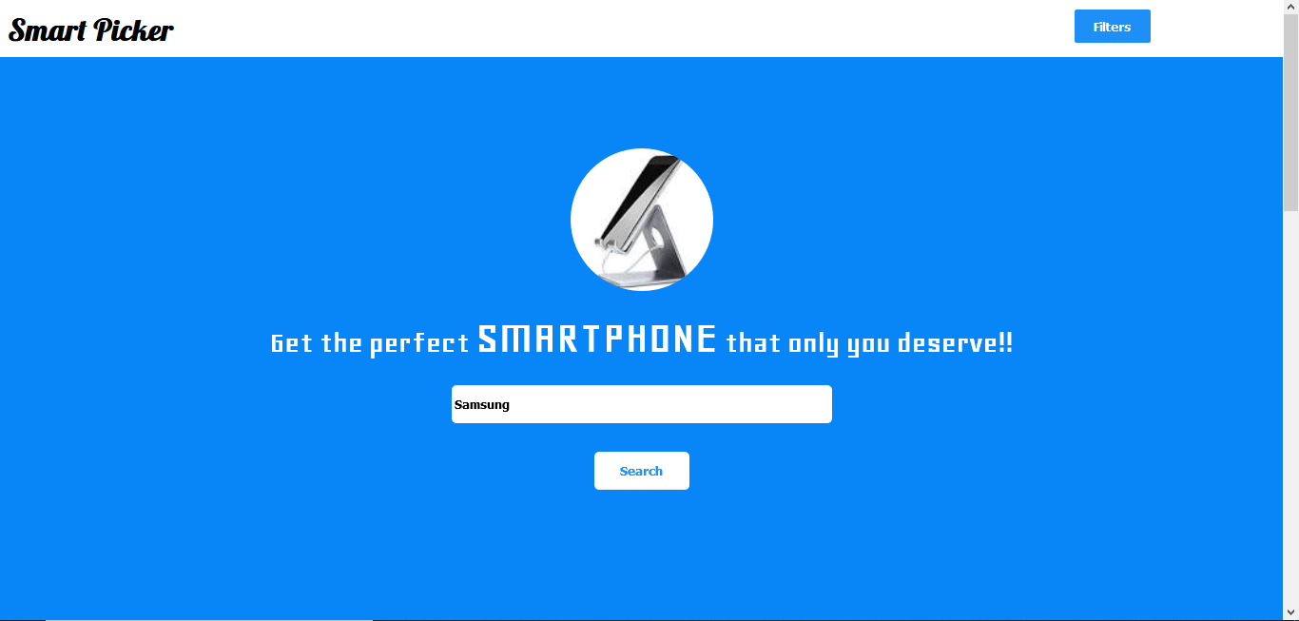
Fig.6.1 Represents the input to be fed into the system

EXPECTED OUTPUT:
The exact products.

ACTUAL OUTPUT:
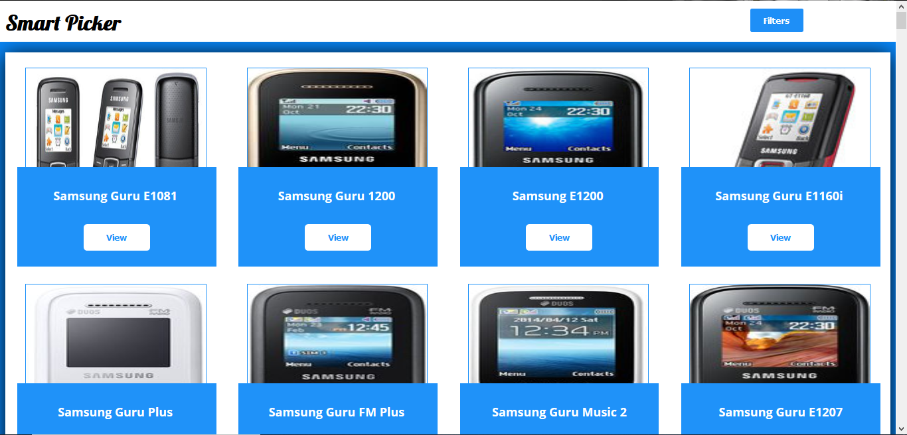
Fig.6.2 Represents the output from the system

6.2.2 INTERGRATION TESTING:
Integration Testing is performed on the system to verify that required list of mobiles is obtained when filters is applied as shown in the (Fig.6.2).

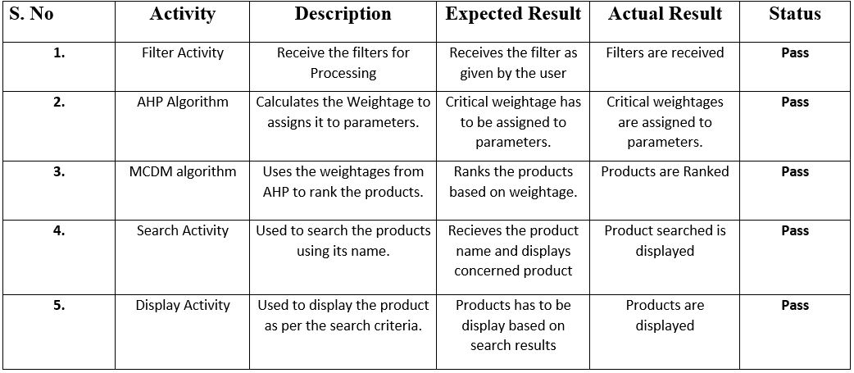
Fig.6.3 Represents the test case of overall search results

6.3 CONCLUSION
System testing is the testing conducted on a complete integrated system to evaluate the system's compliance with its specified requirements. System testing takes the input, all of the integrated components that have passed all the tests.

CHAPTER 7
CONCLUSION

Advancement in search and filter methods has to check out parametric conditions and necessities of user’s interest accurately for tomorrow. Maintaining and keeping up accuracy to a standard is always tougher and troublesome with time. Some of the challenges can be anticipated, such as advances in algorithmic conversions that are making it easier to provide accurate search results from database. Here MCDM is being utilized to work around the basic shortcomings in user search results. As the confirm mechanism for searching our view could be suitable and accurately used. Similarly, we have also developed a system that does not allow any user from getting diverted from the search they wanted to perform.

REFERENCES

[1] Achimugu, Philip &amp; Selamat, Ali &amp; Ibrahim, Roliana. (2014). ‘A Web-Based Multi-Criteria Decision-Making Tool for Software Requirements Prioritization’. 10.1007/978-3-319-11289-3_45.
[2] Adunlin, G., Diaby, V., &amp; Xiao, H. (2015). ‘Application of multicriteria decision analysis in healthcare: a systematic review and bibliometric analysis. Health expectations: an international journal of public participation in health care and health policy’, 18 6, 1894-905.
[3] Athawale, Vijay & Chakraborty, Shankar. (2010). ‘Facility Layout Selection Using PROMETHEE II Method’.
[4] Balali, Vahid & Zahraie, Banafsheh & Roozbahani, Abbas. (2012). ‘Integration of ELECTRE III and PROMETHEE II decision-making methods with an interval approach: Application in selection of appropriate structural systems. Journal of Computing in Civil Engineering’. 28. 297-314. 10.1061/(ASCE)CP.1943-5487.0000254.
[5] Beynon, Malcolm & Barton, Harry. (2008). ‘A PROMETHEE based uncertainty analysis of UK police force performance rank improvement. International Journal of Society Systems Science’. 1. 176-193. 10.1504/IJSSS.2008.021918.
[6] Danesh, Darius & Ryan, Mike & Abbasi, Alireza. (2017). ‘A Systematic Comparison of Multi-criteria Decision-Making Methods for the Improvement of Project Portfolio Management in Complex Organisations’. International Journal of Management and Decision Making. 16. 1. 10.1504/IJMDM.2017.10005690
[7] Frini, Anissa & Sirois, Caroline & Laroche, Marie-Laure. (2020). ‘A Hybrid Delphi Multi-criteria Sorting Approach for Polypharmacy Evaluations’. 10.1007/978-981-32-9808-8_22.
[8] Khalaji, Majid. (2012). ‘Improving Recommender Systems in E-Commerce Using Similar Goods’. Journal of Software Engineering and Applications. 05. 96-101. 10.4236/jsea.2012.52015.
[9] Mühlbacher, Axel &amp; Kaczynski, Anika. (2015). ‘Making Good Decisions in Healthcare with Multi-Criteria Decision Analysis: The Use, Current Research and Future Development of MCDA’. Applied health economics and health policy. 14. 10.1007/s40258-015-0203-4.
[10] Oses, U. & Roji, Eduardo & Cuadrado, J. & M., Larrauri. (2018). ‘Multiple-Criteria Decision-Making Tool for Local Governments to Evaluate the Global and Local Sustainability of Transportation Systems in Urban Areas: Case Study. Journal of Urban Planning and Development’. 144. 10.1061/(ASCE)UP.1943-5444.0000406.
[11] Roy, Sharmistha. (2018). ‘COMPARATIVE STUDY OF SOME MCDM TECHNIQUES FOR E-COMMERCE APPLICATIONS’. International Journal of Advanced Research in Computer Science. 9. 440-443. 10.26483/ijarcs. v9i1.5361.
[12] Srivastava, Abhishek & Singh, Bhakti & Chhabra, Anshul & Majumdar, (2017). ‘Application and use of MCDM technique in software industry’. 487-491. 10.1109/ICTUS.2017.8286058.
[13] P. Taillandier and S. Stinckwich, ‘Using the PROMETHEE multi-criteria decision-making method to define new exploration strategies for rescue robots,’ 2011 IEEE International Symposium on Safety, Security, and Rescue Robotics, Kyoto, 2011, pp. 321-326.
[14] Zeng, Z. (2010). ‘A Commodity Information Search Model of E-Commerce Search Engine Based on Semantic Similarity and Multi-Attribute Decision Method.’
[15] Zhao, Hongju & Peng, Yi & Li, Wei. (2013). ‘Revised PROMETHEE II for improving efficiency in emergency response. Procedia Computer Science’. 17. 181–188. 10.1016/j.procs.2013.05.025.

APPENDIX
Prriyamvadhaa M A, Purushothoman U, Saadana S. “Mobile Phone Recommender using Multi Criteria Decision Making algorithm”, International Conference on Engineering Digital Green Era 2020, Organised by the Organization of Rajalakshmi Engineering College, Chennai In Association With IEEE, Chennai on 12th March 2020.

